Historical polar bear enclosure and seal enclosure, Zoo Wuppertal, Germany
In 1911 an impressive, artificial rock landscape based on the Hagenbeckian Nordland panorama was presented in what is now Wuppertal Zoo (Zoo in Elberfeld), which allowed the visitor to observe polar bears, seals and mountain goats at the same time.
As the polar bear complex, which had been redesigned several times, no longer met today's requirements for Wuppertal polar bear keeping, Zooverein Wuppertal commissioned ZOOQUARIUMDESIGN 's planning team with a feasibility and concept study to combine the historic polar bear facility with the upstream seal enclosure into a new and trendsetting enclosure. At the same time the stocking of animals was to be examined and proposals for the future stocking should be submitted.
Furthermore, the client attached great importance to an economical, but also sustainable solution that could be well integrated into the overall concept of this historic zoo.
As a result, the ZOOQUARIUMDESIGN planning team presented a sustainable concept for a new seal enclosure in which the two historic enclosures (minimally invasive) were connected. An innovative, integrated "Environmental Enrichment Concept" has been used to modify the historic facilities into a modern breeding facility for seals.
The special enclosure design entices the animals to great activity, which increased the visitor attractiveness and education to a special degree.
Area: approx. 1650 m²
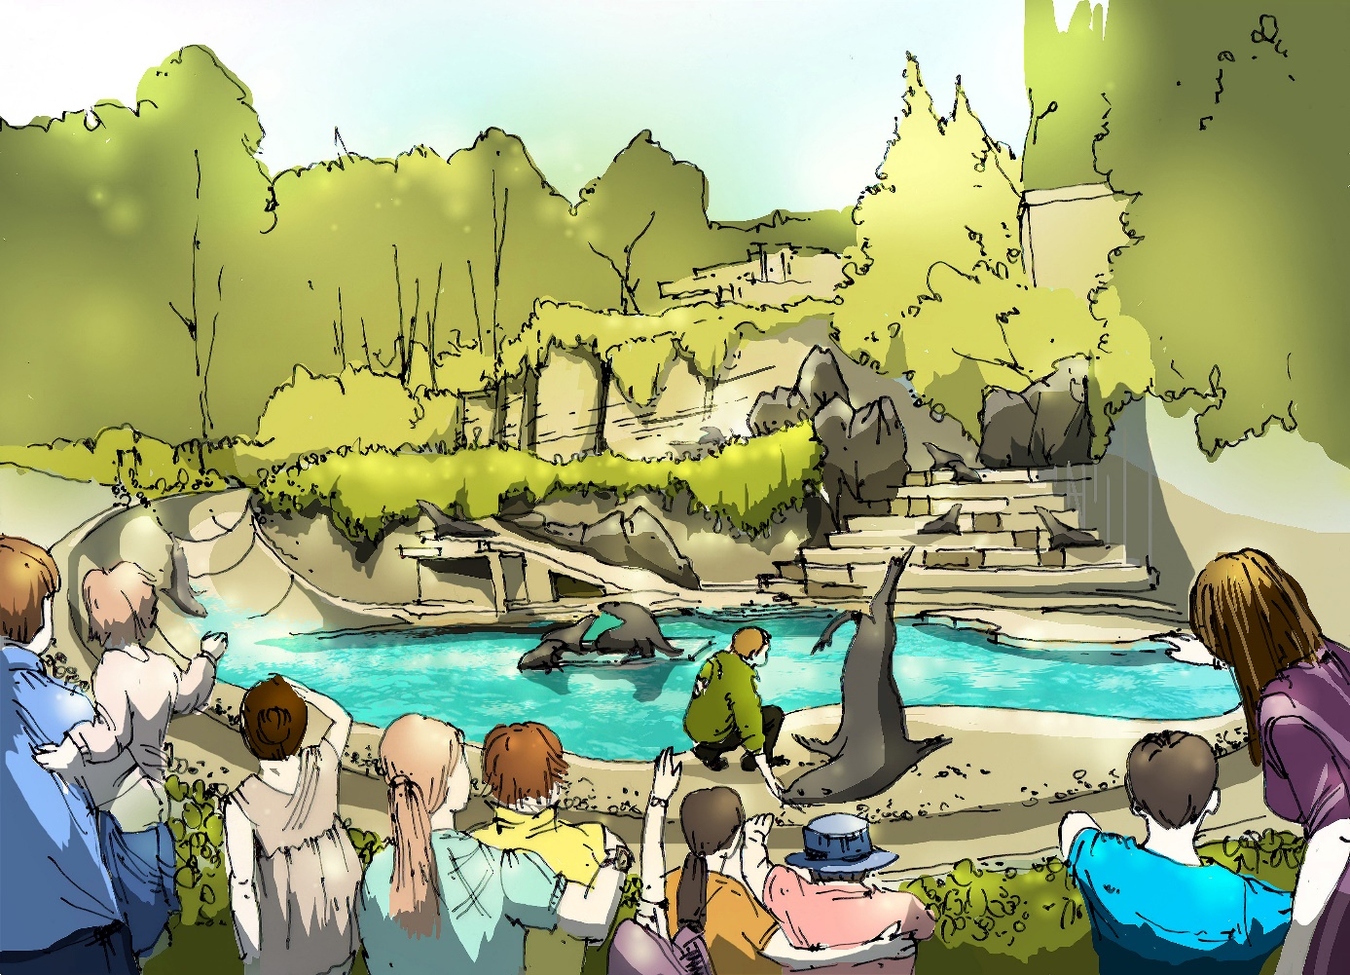

Nicht auf Webseite
KGR 300: 752,292.50 € / 895,228.08 €
KGR 400: 500,000.00 € / 595,000.00 €

